VITyarthi
Build Your Own Project
Course Project Report
Project Title: Travel and Packing Assistance
Submitted By: Mayank Agrawal
Registration Number: 25BSA10105
Program: Cloud Computing
Course Code: CSA2001
Course Name: Fundamentals In AI and ML
Faculty: Rakesh
Institution: Vellore Institute of Technology, Bhopal
Academic Year: 2025-29

Introduction
Travel planning often becomes stressful, especially when determining what to pack. The Smart Travel & Packing Assistant aims to simplify this process by generating a personalized packing list based on destination, duration, weather, and travel purpose. The system also provides relevant travel tips and allows users to track packed and pending items.
Problem Statement
People frequently struggle with packing efficiently, leading to forgotten essentials or overpacking. There is a need for an intelligent, customizable, and user-friendly digital assistant that provides tailored packing suggestions along with useful travel guidance.
Objectives

objectives for the Smart Travel & Packing Assistant project:
- To generate a personalized packing list based on destination, trip duration, weather, and travel type.
- To organize packing items into clear categories for better usability and planning.
- To provide weather-specific and activity-based recommendations to ensure preparedness.
- To offer interactive item-tracking by allowing users to mark packed and remaining items.
- To deliver relevant travel tips tailored to leisure, business, or adventure trips.
- To simplify travel preparation and reduce the chances of forgetting essential items
Functional Requirements
- • System shall allow users to input destination, duration, weather, and travel type.
- • System shall generate a categorized packing list.
- • System shall adjust the number of clothing items based on trip duration.
- • System shall include weather-specific and activity-based items.
- • System shall allow users to mark items as packed.
- • System shall display remaining unpacked items.
- • System shall provide travel tips based on travel type.

Non-Functional Requirements
- Usability — System must be simple and intuitive to use.
- • Performance — Must respond instantly to user inputs.
- • Maintainability — Code should be modular and easy to update.
- • Reliability — Output must be accurate and consistent.
- • Portability — Should run on any system with Python installed.

System Architecture
- The system follows a simple modular architecture:
• packing_data.py — Stores packing categories, weather items, and tips.
• main.py — Handles user interaction, list generation, and output display.
Data flows from user input to decision logic, which then produces the final packing list.

Design Diagrams
1. Use Case Diagram

2. Workflow Diagram
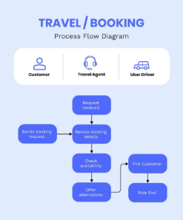
3. Class Diagram
TaskManager
- packing_data
+ add_data()
+ edit_data()
+ view_data()
+ save_data()

Storage
+ load_tasks()
+ save_tasks()

4. Sequence Diagram

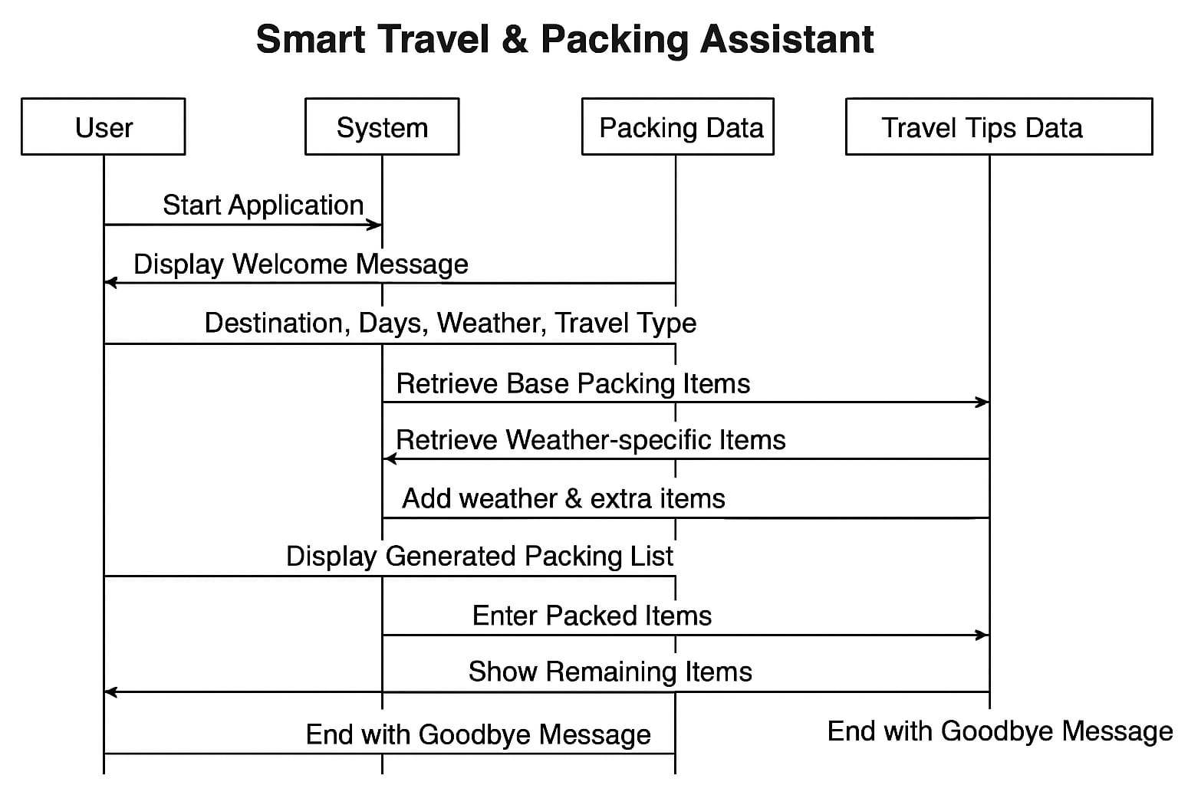
5. ER Diagram

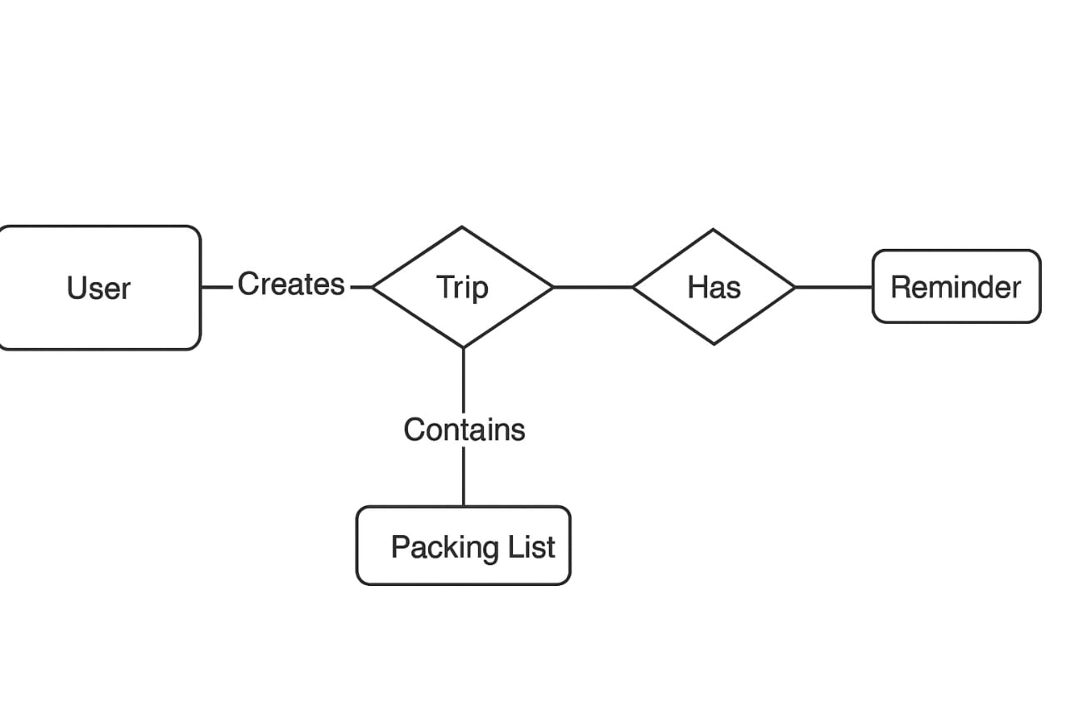

Flowchart/ algorithm
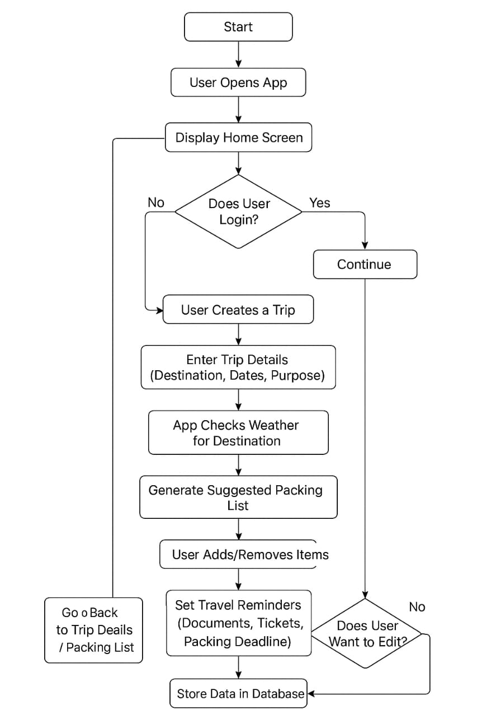
Design Decisions & Rationale
- Python was chosen due to simplicity and readability.
- Dictionary-based data storage ensures flexibility and easy modification.
- Modular separation improves maintainability and scalability.
- Console-based interface ensures wide accessibility without GUI dependency.
Implementation Details
The system is implemented in Python using two files:
• packing_data.py — Contains predefined item lists for packing.
• main.py — Collects inputs, generates lists, and manages packing interaction.
The program multiplies clothing quantities based on trip duration and dynamically adds weather or activity-specific items.

Screenshots / Output
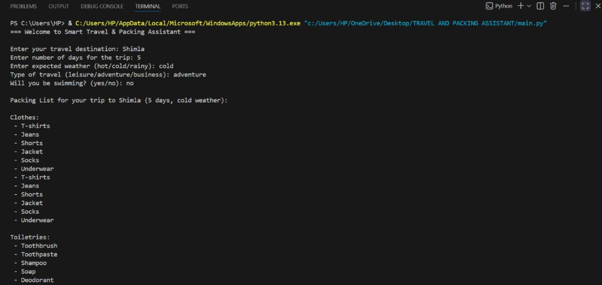
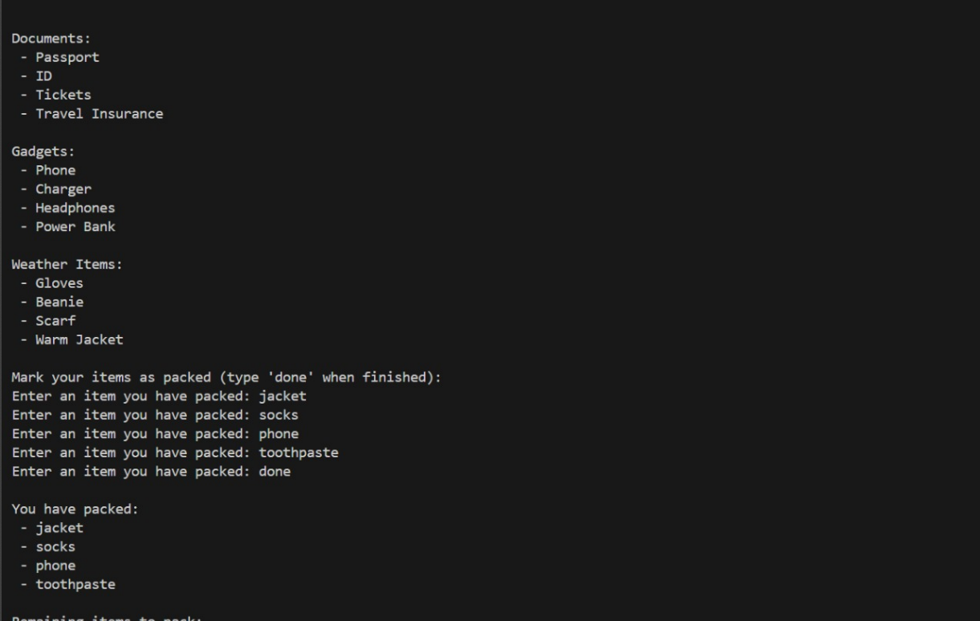
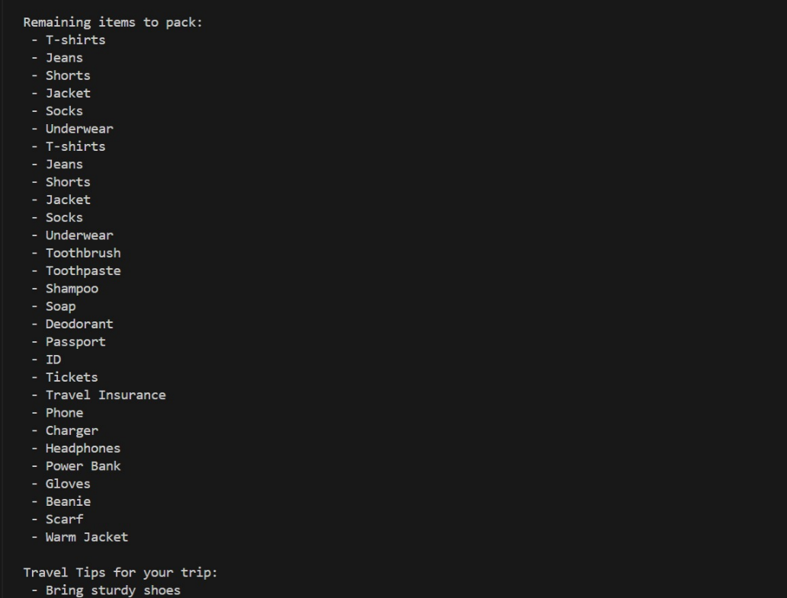
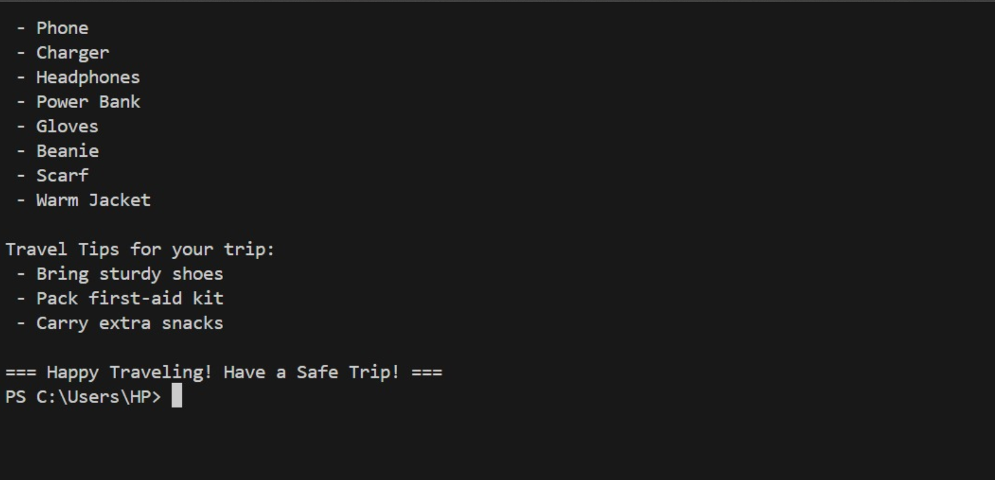

Testing Approach
- Manual input testing performed for multiple destinations, durations, and travel types.
- Boundary testing to ensure proper clothing quantity scaling.
- Validation of weather-specific packing logic.
- Usability testing to confirm clarity of console interaction.
Challenges Faced
• Ensuring packing recommendations remain relevant across different travel scenarios.
• Handling user variations and unexpected input formats.
• Balancing simplicity and flexibility in data structure.

Learnings & Key Takeaways
Improved understanding of modular programming.
• Learned how to structure functional and non-functional requirements.
• Experienced importance of user-centered system design.
• Strengthened Python dictionary and input handling skills.
Future Enhancements
Develop graphical user interface (GUI).
• Integrate real-time weather API.
• Enable cloud-based user profile and storage.
• Include automatic packing reminders and notifications.
• Generate downloadable or printable packing lists.

References
• Python Official Documentation — https://www.python.org/
• Project codebase — packing_data.py and main.py
• General travel planning resources and guidelines

